**ST. THERESA’S ARTS & SCIENCE COLLEGE FOR WOMEN**

**THARANGAMBADI, MAYILADUTHURAI (DT)**

**PINCODE-609313**



**DEPARTMENT OF MATHEMATICS**

**MEASURING THE PULSE OF PROSPERITY: AN INDEX OF**

**ECONOMIC OF FREEDOM ANALYSIS**

**BY**

**TEAM LEADER:**

**S.INDHUMATHI**

**TEAM MEMBERS:**

**V. AARTHI**

**R. ASHIKA**

**A. BHUVANESWARI**

|  |  |  |
| --- | --- | --- |
| **S.NO** | **PROJECT REPORT TEMPLATE** | **PAGE NO** |
| **1** | **INTRODUCTION** | **1** |
| **2** | **ABSTRACT** | **2** |
| **3** | **EMPATHY MAP** | **3** |
| **4** | **BRAINSTROMING MAP** | **4** |
| **5** | **RESULT** | **5** |
| **6** | **ADVANDAGES AND DISADVANTAGES** | **6** |
| **7** | **APPLICATIONS** | **9** |
| **8** | **CONCLUSION** | **10** |
| **9** | **FUTURE SCOPE** | **11** |
| **10** | **APPENDIX** | **12** |

**INTRODUCTION:**

During the latter half of the 1990s. This paper presents a revised and extended index that

incorporates survey data on property rights/legal structure and on government regulation,

areas of economic freedom that are particularly difficult to measure. These revisions will

be incorporated into future editions of the EFW index.

Other economic freedom indexes have been created. Scully and Slottje (1991) were the

first to develop a systematic measure of economic freedom. Their pioneering work laid the

foundation for subsequent research. Scully has participated in several of the EFW

conferences and provided valuable input to the EFW project during the last decade. The

Heritage Foundation/Wall Street Journal has published an annual index of economic

freedom since 1995 (O’Driscoll et al., 2001). While it covers more countries than the

EFW, the Heritage index is based on measurement procedures that are both less precise

and less transparent than those of EFW. Even more important, since the Heritage measure

covers only the period since the mid-1990s, it is of less value to researchers analyzing the

impact of changes in economic freedom across time periods. In spite of their methodo

logical differences, however, the analysis of Hanke and Walters (1997) indicates that the

country rankings of the Heritage/WSJ and EFW indexes are highly correlated. In addition,

Messick (1996) has constructed an economic freedom index for Freedom House. To date,

this study has not been updated.

This paper will begin with an analysis of the concept of economic freedom and consider

how it differs from political and civil liberties. We will also present the revised structure

and methodology of the more comprehensive EFW index that incorporates survey-based

components designed to improve the measurement of cross-country differences in the legal

structure and regulatory areas. Finally, the new structure will be used to derive both cross-

country summary and area ratings of economic freedom for 1999.

**ABSTRACT:**

The creation and empirical use of economic freedom indices has produced a growing

amount of literature over the last decade. A survey of this literature is provided, and the

difficulty of measuring this concept, as well as the usefulness and limits of the various

indices are discussed. The indices are reduced to their components, and testable models

are used in order to determine which components are most important. Secure property

rights are found to be the most important component driving the results. The results are

consistent with previous studies, which indicate that greater economic freedom is related

to greater growth and wealth.

Not all of the components of an aggregate index have the

same impact or even the same relationship. The aggregate indices are highly correlated at

the international levels, lending support to the reliability of the measures, but there is no

consensus on the appropriate aggregation method. Care should be put on the

interpretation of the actual point estimates when the aggregate index is used empirically,

but the relationships are robust and the indices are very useful and growing

**PURPOSE:**

The debate, whether it be economic, political, or moral, between socialism and

capitalism was a major theme over the last century across many disciplines. The writing

and analysis of these continue, but with the apparent failure and eventual dissolution of

the Soviet Union, they are not viewed as strict alternatives as they once were. In reality,

economies tend to lie somewhere between, and what differs is the degree to which

governments attempt to control economic decisions made by private citizens, and

whether prices are allowed to allocate resources within a largely free market.

Within the economics profession, theory has supported the idea that the level of performance.

In the last two decades, ground has been made in empirical work to support

theory in this area.

This has largely been made possible and supported by the creation of various economic

freedom indices Economic freedom is a fairly broad term, but it relates to the level in which

property that individuals acquire through moral and legal means is protected, and the

freedom in which these individuals can use, give, or exchange that property as they see

fit. It has mainly been treated and thought of as it relates to other desirable outcomes such

as general growth, health, life expectancy, entrepreneurship, and income equality.

However, its relationship to growth and income level has dominated the literature.

The causes of economic growth have been at the center of economic inquiry.

The importance of certain institutions, such as a fair and balanced judiciary, protection of

property rights, and free markets, as they relate to growth and prosperity have been

aspects explored for centuries. In some ways, it begins with Adam Smith arguing that

individuals’ freely pursuing their own interests leads to prosperity for society at large.

Smith stated that, “little else is requisite to carry a state to the highest degree of opulence

**EMPATHY MAP:**

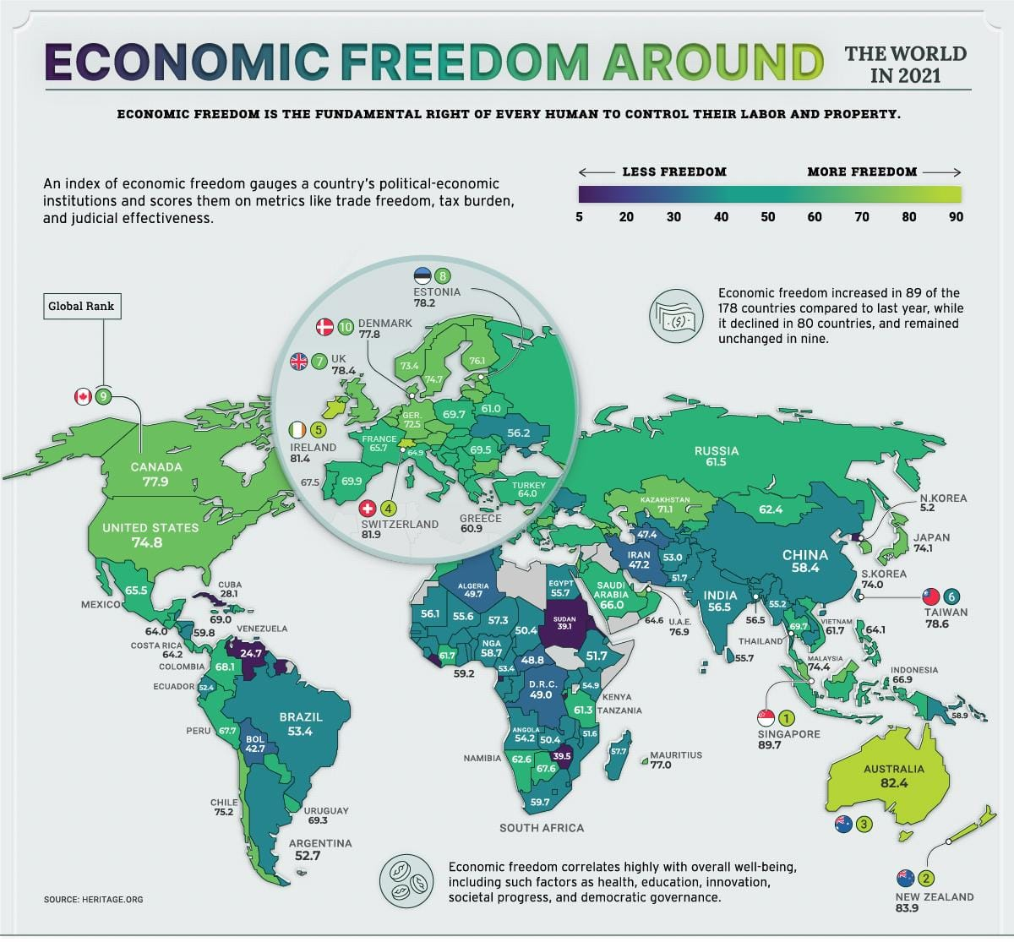**BRAINSTORMING MAP:**

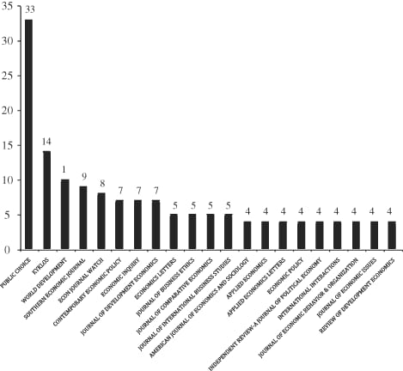

**RESULT:**

In Table 1, we present the summary statistics for the variables included in this study. Annual GDP growth rate has a mean of 3.58 percent per year. The ﬁve-year GDP growth rate has a mean of3.19 percent per year. The economic freedom index has a mean score of 57.53 with a minimum of 1 and maximum of 90.1. Summary statistics for the trade freedom index, ﬁnancial freedom index, business freedom index, labor freedom and ﬁscal freedom indices are also reported in this table.

**Table 1. summary statistics of important variables.**

|  |  |  |  |  |  |
| --- | --- | --- | --- | --- | --- |
| **variable** | **Observation** | **Mean** | **Standard deviation** | **min** | **max** |
| GDP growth rate | 556 | 3.58 | 6.44 | -61 | 104.5 |
| 5 years GDP growth rate | 552 | 3.19 | 3.13 | -14.7 | 16.6 |
| Score 1 | 557 | 57.53 | 16.55 | 0 | 90.1 |
| Trade freedom index | 557 | 72.77 | 17.51 | 0 | 90 |
| Financial freedom index | 557 | 47.27 | 20.70 | 0 | 90 |
| Business freedom | 557 | 63.65 | 18.43 | 0 | 100 |
| Labor freedom | 557 | 60.50 | 18.19 | 0 | 98.5 |
| Fiscal freedom | 557 | 75.51 | 17.96 | 0 | 99.9 |

In Table 2, we present the correlation of the important variables included in the model. The two most important variables are the annual GDP growth rate and the economic freedom index, which have a correlation coefﬁcient of´0.0687. This implies that these two variables are inversely associated with one another. In the case of the ﬁve-year GDP growth rate, we also ﬁnd the correlation co efﬁcient of ´0.1058. This is a surprising result. This means that the higher the economic freedom in a country, the lower the annual GDP growth rate. The trade freedom index, the ﬁnancial freedom index, the business index also have a negative correlation with the annual GDP growth rate. We find a similar correlation with these 3 types of freedom indexes and the 5 year GDP growth rate. However if we consider the association of the annual and 5 year GDP growth rate vis- a-vis labour freedom and fiscal freedom, find a positive association .

|  |  |  |  |  |  |  |
| --- | --- | --- | --- | --- | --- | --- |
|  | ***GDP* Growth rate** | **5 year GDP growth rate** | **Freedom score 1** | **Trade freedom index** | **Financial freedom index** | **Business freedom** |
| GDP growth rate | 1 |  |  |  |  |  |
| 5 years GDP growth rate | 0.4556 | 1 |  |  |  |  |
| Score 1 | -0.0687 | -0.1058 | 1 |  |  |  |
| Trade freedom index | -0.1766 | -0.1785 | 0.769 | 1 |  |  |
| Financial freedom index | -0.1139 | -0.2871 | 0.7806 | 0.6574 | 1 |  |
| Business freedom | -0.0366 | -0.189 | 0.6844 | 0.4535 | 0.5868 | 1 |
| Labor freedom | 0.09 | 0.0205 | 0.4444 | 0.196 | 0.2562 | 0.5165 |
| Fiscal freedom | 0.241 | 0.2615 | 0.3991 | 0.3148 | 0.1008 | 0.2064 |

**ADVANTAGES :**

That economic freedom is an important factor accounting for economic growth is

probable on purely theoretical grounds. The incentives that economic actors

(entrepreneurs, innovators, financiers, industrialists, and others) face are determined in

large part by the institutions in place, which, as Douglass C. North (1990) points

out, can be inefficient or efficient. To the extent that the institutions stimulate

actions that contribute to the production of more valuable output, they contribute

to economic growth.

Institutions that guarantee economic freedom plausibly have The capacity to provide the

Growth –enhancing they promote a high return on productive efforts through low taxation, an

in de-pendent legal system, and the protection of private property; they enable talent to

be allocated to where it generates the highest value (as argued in Murphy, Schleifer,

and Vishny 1991); they foster a dynamic, experimentally organized economy in

which a large amount of business trial and error can take place (Johansson 2001,

chap.

which competition between different actors occurs because regulations and government

enterprises are few; they facilitate predictable and rational

decision making through a low and stable inflation rate; and they promote the

flow of trade and capital investment to where preference satisfaction and re returns

are the highest.

Although certain types of institutional change can be expected to have distinctly

positive growth effects by introducing the kind of incentives just mentioned, institutions per

se, in place over time, can exert an influence not only on the level of wealth

but also on growth rates, all else being equal. In any given period, established institutions set

the economic incentives and influence what economic actors do. Very

high and stable economic freedom, we presume, allows a dynamic economy to function and

grow, even though an increase in economic freedom from a low level might

exert a much more distinct influence on the growth rate for a certain period. Fur-

there more, sustained high growth rates imply ultimately great wealth, and so in the

long term the economic freedom that increases growth can also be expected to

increase accumulated wealth.

If we have theoretical reasons to expect a positive relationship between economic

freedom and economic growth, does empirical evidence confirm this effect. Jagdish

Bhagwati thinks it does: it is not difficult to assert that economic freedom is likely to have a

Favorable effect on economic prosperity, for the simple reason that the last fifty years

of international experience more or less confirms the fact that wherever

governments used markets more and engaged in more open policies in

foreign trade and investment, indeed in more economic freedom of different

kinds, their countries have tended to prosper. By contrast, those countries

that turned inward and had extensive regulations of all kinds on domestic

economic decision-making in production, investment and innovation, are

the countries that have really not done too well.

**DISADVANTAGES :**

**1. Poor Quality**

Since profit maximization is the biggest motivation for firms, they may try to reduce their costs unethically. In many cases, the drive for profit maximization actually incentivizes unethical behavior. Examples of harmful effects of unethical cost reduction measures include polluting the environment or exploiting (overworking, under-paying, preventing workers from unionizing etc.) workers. Government intervention is necessary to limit these harms.

**2. Merit Goods**

Goods and services that are not profitable will not be produced or run. Rural communities will suffer as a result. Examples include transportation and postal services, as well as rural hospitals, which are necessary despite the fact that they may not be profitable to run. In such cases, the government must provide these goods and services so that people do not go with their basic needs unmet.

**3. Excessive Power of Firms:**

Large firms can still dominate certain markets, even where there is some competition. This allows them to maximize their profits by exploiting suppliers (by squeezing their prices down) and consumers (by charging higher selling prices

For example, Amazon is guilty of such practices in the book industry, where they have dictated unfair terms to publishers. Part of the reason that large companies are able to dominate markets is due to economies of scale. The large-scale companies with greater capital and labor resources can beat out smaller companies simply for their size alone, rather than for the quality of their product; if this process continues, they may eventually gain a monopoly over their market.

**4. Unemployment and Inequality**

In a free market economy, certain members of society will not be able to work, such as the elderly, children, or others who are unemployed because their skills are not marketable. They will be left behind by the economy at large and, without any income, will fall into poverty. Their caretakers will also be left out of the economy, because they will not be paid for their necessary caretaking work.

**APPLICATIONS:**

**1) A- Taxes on international trade**

i) Revenue from taxes on international trade as a percentage of exports plus imports

ii) Mean tariff rate

iii) Standard deviation of tariff rates

B) Regulatory trade barriers

i) Hidden import barriers—no barriers other than published tariffs and quotas

ii) Costs of importing—the combined effect of import tariffs, license fees, bank

fees, and the time required for administrative red-tape raises the costs of importing equipment (by 10%or less = score of 10; by more than 50% = score of 0)

C) Actual size of trade sector compared to expected size

D) Difference between official exchange rate and black-market rate

E) International capital market controls

**2) Credit market regulations**

i) Ownership of banks—percentage of deposits held in privately owned banks

ii) Competition—domestic banks face competition from foreign banks

iii) Extension of credit—percentage of credit extended to private sector

iv )Avoidance of interest rate controls and regulations that lead to negative real interest rates

v )Interest rate controls—interest rate controls on bank deposits and/or loans are freely determined by the market

**3) Labour market regulations**

**i)** Impact of minimum wage—the minimum wage, set by law, has little impact on wages because

it is too low or not obeyed

ii) Hiring and firing practices—hiring and firing practices of companies are determined

by private contract

iii) Share of labor force whose wages are set by centralized collective bargaining

iv) Unemployment benefits—the unemployment benefits system preserves the incentive to work.

**FUTURE SCOPE :**

1978 See also Barro 2000. See World Bank 2000.they promote a high return on productive efforts through low taxation, an independent legal system, and the protection of private property; they enable talent tobe allocated to where it generates the highest value (as argued in Murphy, Schleifer, and Vishny 1991); they foster a dynamic, experimentally organized economy in which a large amount of business trial and error can take place (Johansson 2001,chap. 2) and in which competition between different actors occurs because regulations and government enterprises are few; they facilitate predictable and rational decision making through a low and stable inflation rate; and they promote the flow of trade and capital investment to where preference satisfaction and returns are the highest.

Although certain types of institutional change can be expected to have distinctly positive growth effects by introducing the kind of incentives just mentioned, institutions per se, in place over time, can exert an influence not only on the level of wealth but also on growth rates, all else being equal. In any given period, established institution economic incentives and influence what economic actors do. Very high and stable economic freedom, we presume, allows a dynamic economy to function and grow, even though an increase in economic freedom from a low level might exert a much more distinct influence on the growth rate for a certain period. Fur-there more, sustained high growth rates imply ultimately great wealth, and so in the long term the economic freedom that increases growth can also be expected crease accumulated wealth.

If we have theoretical reasons to expect a positive relationship between **economic freedom** and economic growth, does empirical evidence confirm this effect? Jagadish Bhagwati thinks it does it is not difficult to assert that economic freedom is likely to have a favorable effect on economic prosperity, for the simple reason that the last fifty years of international experience more or less confirms the fact that wherever governments used markets more and engaged in more open policies info reign trade and investment, indeed in more economic freedom of different kinds, their countries have tended to prosper.

By contrast, those countries that turned inward and had extensive regulations of all kinds on domestic economic decision-making in production, investment and innovation, are the countries that have really not done too well. (1994, 4)8A simple mapping by Gwartney and Lawson (2002) to a large extent supports this position, as is clear from figure 1.9As the figure shows, the one-fifth of countries

**CONCLUSION :**

On the international and national level, a greater level of economic freedom is

found to be correlated with greater wealth, and an increase in economic freedom means

an increase in growth. The relationship is complex though, and not every component that

makes up the international indices is positively correlated. It is not clear if the

relationship found with the size of government among underdeveloped countries is the

same as developed countries. The results in this area are likely affected by a reverse

casual relationship.

The IEF and EFW are strongly correlated, and regarding the U.S, the trend is the

same between the two international indices and the average of the EFNA. The IEF has a lower

ranking of all countries on average, and little inconsistency could be detected.

A criticism of these indices has been that they are created with a political axe to

grind; that since those who construct them are in favor of free markets, they are biased

and are able to take the data they want, while leaving out other data, and support the

conclusion they are seeking. It is true that some data is left out, because it must be so.

This is the case with all social science. It is not possible to account for all the possible

variables that affect people’s behavior.

Each index studied here purports to use 3rd party data to make the results as

objective as possible. An advantage to using EFW over IEF is simply the fact that they

provide the raw data used to construct the index. This is a valuable contribution to

academic research. What variables and attributes of a society that constitutes economic.

**Appendix: ECONOMIC FREEDOM**

Note: GCR Global Competitiveness Report; ICRG International Country Risk Guide

**1. Size of Government: Expenditures, Taxes, and Enterprises**

A. General government consumption spending as a percentage of total consumption

B. Transfers and subsidies as a percentage of GDP

C. Government enterprises and investment as a percentage of GDP

D. Top marginal tax rate (and income threshold to which it applies)

**2. Legal Structure and Security of Property Rights**

A. Judicial independence: The judiciary is independent and not subject to interference by the

government or parties in disputes (GCR)

B. Impartial courts: A trusted legal framework exists for private businesses to

challenge the legality of government actions or regulation (GCR)

C. Protection of intellectual property (GCR)

D. Military interference in rule of law and the political process (ICRG)

E. Integrity of the legal system (ICRG)

**3. Access to Sound Money**

A. Average annual growth of the money supply in the past five years minus

average annual growth of real GDP in the past ten years

B. Standard inflation variability in the past five years

C. Recent inflation rate

D. Freedom to own foreign-currency bank accounts domestically and abroad

**4. Freedom to Exchange with Foreigners**

A. Taxes on international trade

i). Revenue from taxes on international trade as a percentage of exports plus imports

ii). Mean tariff rate

iii). Standard deviation of tariff rates

B. Regulatory trade barriers

i). Hidden import barriers: no barriers other than published tariffs and quotas (GCR)

ii). Costs of importing: the combined effect of import tariffs, license fees,

bank fees, and the time required for administrative red tape raises costs of importing equipment;

10 percent or less; 0 more than 50 percent (GCR)

C. Actual size of trade sector compared to expected size

D. Difference between the official exchange rate and the black-market rate

E. International capital market controls

i). Access of citizens to foreign capital markets and foreign access to domestic capital markets (GCR)

ii). Restrictions on the freedom of citizens to engage in capital-market exchange with foreigners’

index of capital controls among thirteen IMF categories

**5. Regulation of Credit, Labor, and Business**

A. Credit-Market Regulations

i). Ownership of banks: percentage of deposits held in privately ownedbanks

ii). Competition: Domestic banks face competition from foreign banks(GCR)

iii). Extension of credit: percentage of credit extended to private sector

iv). Avoidance of interest-rate controls and regulations that lead tonegative real interest rates

v). Interest-rate controls: Interest-rate controls on bank deposits or loans

or both are freely determined by the market (GCR)

B. Labor-Market Regulations

i). Impact of minimum wage: the minimum wage, set by law, has littleimpact on wages because it is

too low or not obeyed (GCR)

ii). Hiring and firing practices of companies determined by privatecontract (GCR)

iii). Share of labor force whose wages are set by centralized collectivebargaining (GCR)

iv). Unemployment benefits system preserves the incentive to work (GCR)

v). Use of conscripts to obtain military personnel

